Software Quality Assurance (SQA) – 1ST Week Project Task
Name: Dariya Hashmi -- DHC (2403)
Project Title: Test Case Documentation

1. Sample Website
For this testing project, the selected website is: Amazon
Amazon is an online e-commerce platform where users can:
- Search products
- Add products to cart
- Place orders
- Manage account
- Track orders
The purpose of testing is to verify whether the main features of the website work correctly.

2. Testing Types
The following types of testing were performed:

Functional Testing
Functional testing checks whether the system functions work according to requirements.
Example:
- Login functionality
- Search functionality
- Add to cart
- Checkout

User Interface (UI) Testing
UI testing checks the appearance and usability of the website.
Example:
- Navigation bar
- Buttons
- Layout
- Forms

3. Identify Functional and UI Issues

Functional Issue 1
Sometimes when users try to login with valid credentials, the page takes too long to load.

Functional Issue 2
The system allows adding products to the cart even when the product is out of stock.

UI Issue 1
Product images on some pages are not properly aligned on smaller screens.

UI Issue 2
The checkout button is not very prominent which may confuse new users.

Test Case Document

FEATURE 1: User Login

TC_01 – Valid Login
Test ID: TC_LOGIN_01
Test Description: Verify that a user can login with valid credentials.
Preconditions:
User must already have a registered account.
Test Steps:
- Open Amazon website
- Click on Login
- Enter valid email address
- Enter correct password
- Click Login button
Expected Result:
User should login successfully and be redirected to homepage.
Actual Result:
User logged in successfully.
Status: Pass

TC_02 – Invalid Login
Test ID: TC_LOGIN_02
Test Description: Verify login with invalid credentials.
Preconditions:
User must have a registered account.
Test Steps:
- Open login page
- Enter incorrect email or password
- Click Login
Expected Result:
Error message should appear.
Actual Result:
Error message displayed.
Status: Pass

FEATURE 2: Search Product

TC_03 – Search Product with Valid Keyword
Test ID: TC_SEARCH_01
Test Description: Verify that relevant products appear when user searches with valid keyword.
Preconditions:
User is on homepage.
Test Steps:
- Enter "Laptop" in search bar
- Press Enter
Expected Result:
Relevant products should appear.
Actual Result:
Products displayed successfully.
Status: Pass

TC_04 – Search Product with Invalid Keyword
Test ID: TC_SEARCH_02
Test Description: Verify system behavior when invalid keyword is entered.
Preconditions:
User is on homepage.
Test Steps:
- Enter random keyword "abcxyz123"
- Press Enter
Expected Result:
System should display message like "No results found".
Actual Result:
No results message displayed.
Status: Pass

FEATURE 3: Add to Cart

TC_05 – Add Product to Cart
Test ID: TC_CART_01
Test Description: Verify user can add product to cart.
Preconditions:
User is on product page.
Test Steps:
- Open any product
- Click "Add to Cart"
Expected Result:
Product should be added to cart successfully.
Actual Result:
Product added successfully.
Status: Pass

TC_06 – Remove Product from Cart
Test ID: TC_CART_02
Test Description: Verify user can remove product from cart.
Preconditions:
Product already added to cart.
Test Steps:
- Open cart
- Click Remove button
Expected Result:
Product should be removed.
Actual Result:
Product removed successfully.
Status: Pass

FEATURE 4: Checkout

TC_07 – Proceed to Checkout
Test ID: TC_CHECKOUT_01
Test Description: Verify user can proceed to checkout.
Preconditions:
Product added to cart.
Test Steps:
- Open cart
- Click Checkout
- Enter shipping address
- Select payment method
Expected Result:
User should proceed to order confirmation page.
Actual Result:
Checkout process completed successfully.
Status: Pass

FEATURE 5: User Registration (Signup)

TC_08 – Valid Registration
Test ID: TC_SIGNUP_01
Test Description: Verify that a new user can register with valid details.
Preconditions: User must not already have an account.
Test Steps:
- Open Amazon website
- Click on “Create Account”
- Enter valid name
- Enter valid email
- Enter strong password
- Click Register
Expected Result:
Account should be created successfully.
Actual Result:
Account created successfully.
Status: Pass

TC_09 – Registration with Existing Email
Test ID: TC_SIGNUP_02
Test Description: Verify system does not allow registration with already registered email.
Preconditions: Email already exists in system.
Test Steps:
- Open Create Account page
- Enter existing email
- Click Register
Expected Result:
System should display error message.
Actual Result:
Error message displayed.
Status: Pass

TC_10 – Password Validation
Test ID: TC_SIGNUP_03
Test Description: Verify password must meet minimum requirements.
Preconditions: None
Test Steps:
- Open registration page
- Enter weak password (12345)
- Click Register
Expected Result:
System should show password validation message.
Actual Result:
Validation message displayed.
Status: Pass

FEATURE 6: Product Filter

TC_11 – Apply Price Filter
Test ID: TC_FILTER_01
Test Description: Verify products are filtered by selected price range.
Preconditions: User on product listing page.
Test Steps:
- Search for “Mobile”
- Select price range filter
- Apply filter
Expected Result:
Only products within selected price range should appear.
Actual Result:
Filtered products displayed correctly.
Status: Pass

TC_12 – Apply Brand Filter
Test ID: TC_FILTER_02
Test Description: Verify brand filter works correctly.
Preconditions: On product listing page.
Test Steps:
- Search for product
- Select brand checkbox
Expected Result:
Only selected brand products should appear.
Actual Result:
Correct products displayed.
Status: Pass

FEATURE 7: Order History

TC_13 – View Order History
Test ID: TC_ORDER_01
Test Description: Verify user can view previous orders.
Preconditions: User logged in and has previous orders.
Test Steps:
- Login
- Go to “My Orders”
Expected Result:
List of previous orders should display.
Actual Result:
Orders displayed correctly.
Status: Pass

TC_14 – Track Order
Test ID: TC_ORDER_02
Test Description: Verify user can track shipment status.
Preconditions: Order already placed.
Test Steps:
- Go to My Orders
- Click Track Order
Expected Result:
Shipment tracking details should appear.
Actual Result:
Tracking details displayed.
Status: Pass

FEATURE 8: Logout

TC_15 – Logout Functionality
Test ID: TC_LOGOUT_01
Test Description: Verify user can logout successfully.
Preconditions: User logged in.
Test Steps:
- Click Account menu
- Click Logout
Expected Result:
User should be logged out and redirected to homepage.
Actual Result:
User logged out successfully.
Status: Pass

BUG REPORT:

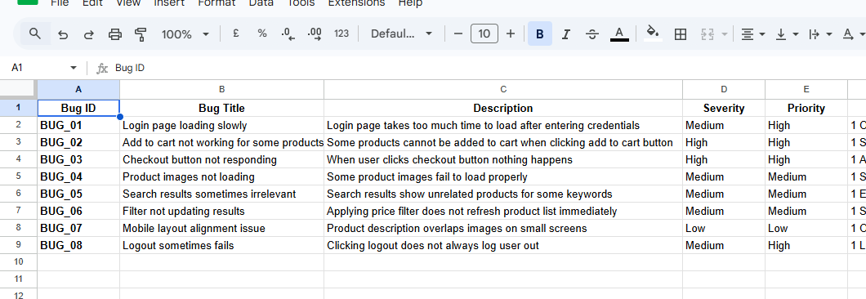

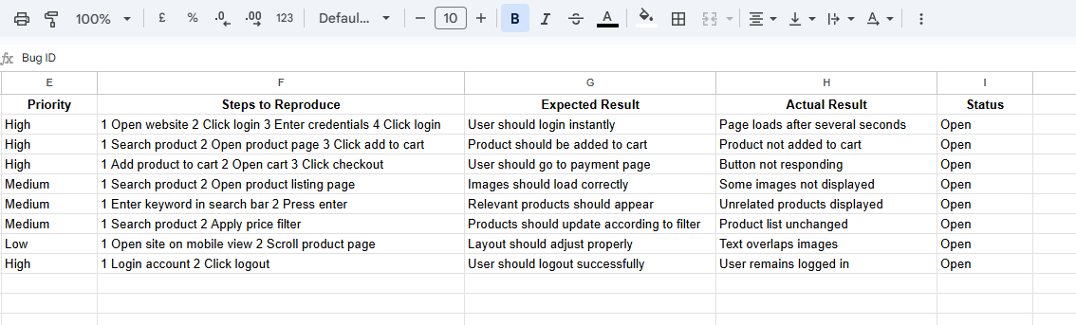

Github repoistry link:
https://github.com/dariyahashmi2602-source/Bug_Report_SQA

